# Overview

In this guided practice you will install Active Directory on the first domain controller in an Active Directory forest.

# Objectives

* Be able to install Active Directory as a child domain, additional domain controller, and a new domain.
* Be able to verify the installation of Active Directory.

# Prerequisites

Guided practice - Establishing Prerequisites for AD Installation is complete.

# Scenario

The prerequisites for Active Directory installation have been established and you now wish to install Active Directory on your domain controllers. The first to be created will be the domain for the ABS Corporation. The Research division domain will then be created as a child domain in a separate guided practice. Finally, the **LameTech** domain will be created as a new tree within the existing forest in the final guided practice.

# Tasks

## Creating the forest root domain

1. **Start** the **CIS256-DC1** virtual machine.
2. **Logon** as the **administrator.**
3. **Open Server Manager and start the Active Directory Domain Services Installation Wizard and** promote this machine to a domain controller by **selecting** the **link** in the **notifications** menu as shown in the figure below.
4. 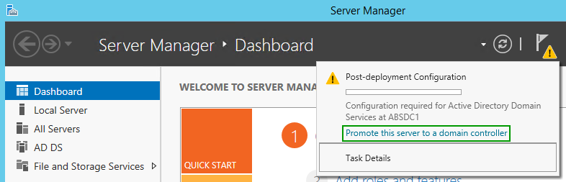On the **Deployment Configuration** page of the wizard, select **Add a new forest** radio button and **type abscorp.com** in the **Root domain** name text box. **Click** the **Next** button.
5. On the **Domain Controller options** page of the wizard, **verify** the **Forest** and **Domain** **functional** **levels** are **Windows Server 2016,** the **Domain Name System (DNS) server** **checkbox** is **selected**, and **type** **Password1** in the **Password** and **Confirm password** text boxes as shown in the figure below. **Click** the **Next** button.
6. 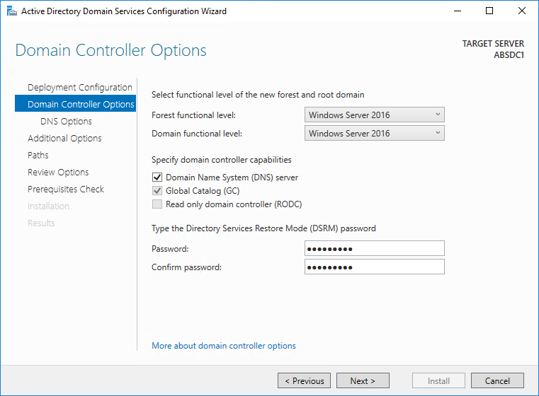On the **DNS Options** page of the wizard, you will get a message about not being able to create a DNS delegation. **Read** the **message** and **click** the **Next** button.
7. On the **Additional Options** page of the wizard, verify that **ABSCORP** is listed in the **NetBIOS domain name**: textbox and **click** the **Next** button.
8. On the **Paths** page of the wizard, **note** the **location** of the Database, Log Files, and SYSVOL folder and **click** the **Next** button.
9. On the **Review Options** page of the wizard, review the settings and **click** the **Next** button.
10. On the **Prerequisites** **Check** page of the wizard **read** the **warnings** and **click** the **Install** button.
11. Reboot your system when done.

## Verify the installation of Active Directory

Logon to your system as the administrator and verify that Active Directory was properly installed by verifying the following:

1. Active Directory Tools were installed.
   1. AD Users and Computers
   2. AD Sites and Services
2. The **Sysvol** share was created.
3. The Active Directory database is in the proper location.
4. DNS has the required service locator records.
5. Review the logs in the Event Viewer and address any errors.
6. Run the **dcdiag** command and resolve any relevant errors.

## Additional Configurations

### Creating a personal account and an administrative account

Create the following accounts in Active Directory:

1. **Create** an unprivileged user **account** using your **first initial + lastname** (e.g. kazevedo). Set the password to **Password1**.
2. **Create** a user **account** named **ABSAdmin**. Set the password to **Password1**.
3. **Add** **ABSAdmin** to the **Domain Admins** and **Enterprise Admins** groups

When performing guided practices, you should logon to your computer using your personal account and use the **ABSAdmin** account when prompted to perform administrative tasks.

### Additional DNS Configurations

1. **Add** a **primary** AD integrated **reverse** **lookup** zone for the **10.1.1.0/24** network.
2. Update your pointer record so that it appears in this zone.

### Installing and Configuring DHCP

Install DHCP on your server to support clients that will be connected to the local network. Name the scope after the location and issue IP addresses from .10 to .240 for your local subnet.

### aCTIVATE & Join DT1 client to ABScorp domain

1. The KMS server for ECPI is located at **10.10.6.20**. In **Windows PowerShell (admin)**, issue the following commands to activate the Windows server systems.

slmgr /skms 10.10.6.20

slmgr /ato

The expected response is **Product activated successfully**.

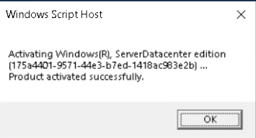

1. If the response from **slmgr /ato** is ***The activation server determined that the specified product key could not be used***, issue the following commands

slmgr /ipk WMDGN-G9PQG-XVVXX-R3X43-63DFG

slmgr /ato

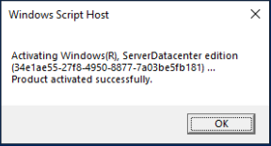

1. **Join** the **CIS256-Client1** virtual machine to the **ABSCorp.com** domain.
2. Add **Domain Users** groupto the **Remote Desktop Users** group on **CIS256-Client1.**

# Submission Requirements

1. **Download** the **grading** **script** from the assignment page to the **C:\Scripts** folder.
2. Check your lab by running the following command:

Invoke-Pester -Path C:\Scripts\GP04-Installing_Active_ Directory.test.ps1

**Note**: You will see a security warning when running the script. Enter **R** to run the script.

If you want to see more detail, add **-Output Detailed** to the command. This may assist you with troubleshooting

Invoke-Pester -Path C:\Scripts\GP04-Installing_Active_ Directory.test.ps1 -Output Detailed

1. You should not see any red in the output. Red in the PowerShell way of telling you that an error condition exists. Most of the time, the output will tell you what is wrong. If it is not obvious, contact your teacher and ask for assistance. You will be learning PowerShell during this term. **Correct** any **errors** you may have and run the script until all the output has no red. You should see the output like the images below.

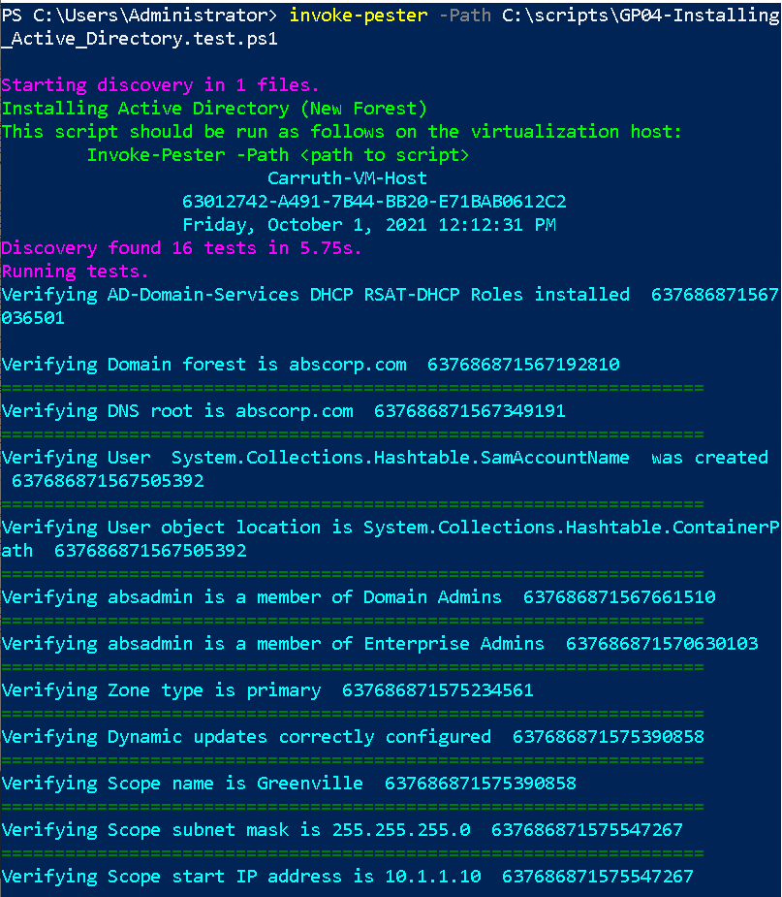

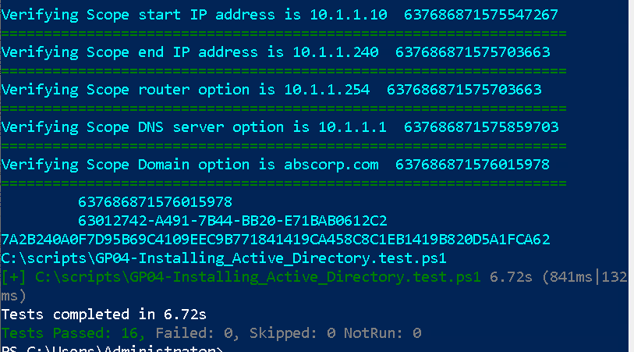

1. Capture a snippet that shows the PowerShell Command and all its output. If you must use more than one snippet to capture the output, you must have at least **one line of overlap** in the snippets. The text in the snippets **must be legible** when pasted into the Word document. Paste the snippet(s) into a **new** **Word** **document.**
2. **Upload** the **document** in the submission area for the assignment.